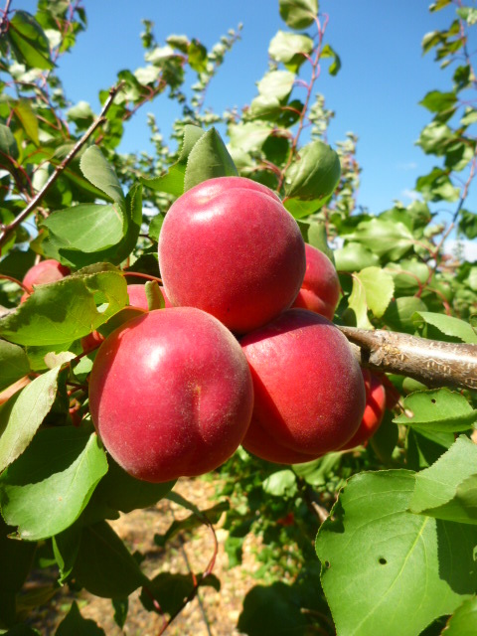 |  | Apricot  Variety – Rubissia  Picking date – 25-30 May  Shape – Oval  Firmness – Good  Cracking – No  Skin color – Red  Size – AA-AAA  Sugar level – 15° Brix
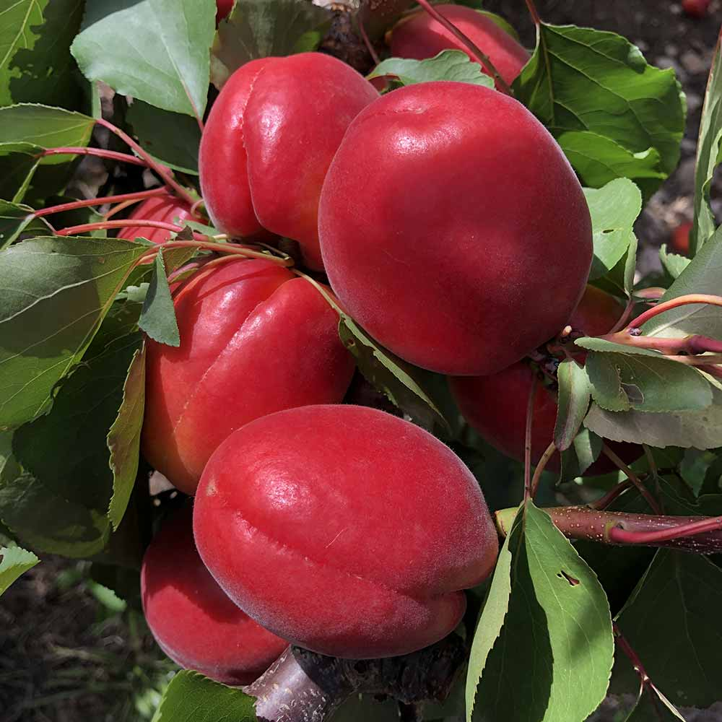 |  | Apricot  Variety – Bolero  Picking date – 1-10 June  Shape – Oval, elongated  Firmness – Good  Cracking – No  Skin color – Red  Size – AA-AAA  Sugar level – 15° Brix
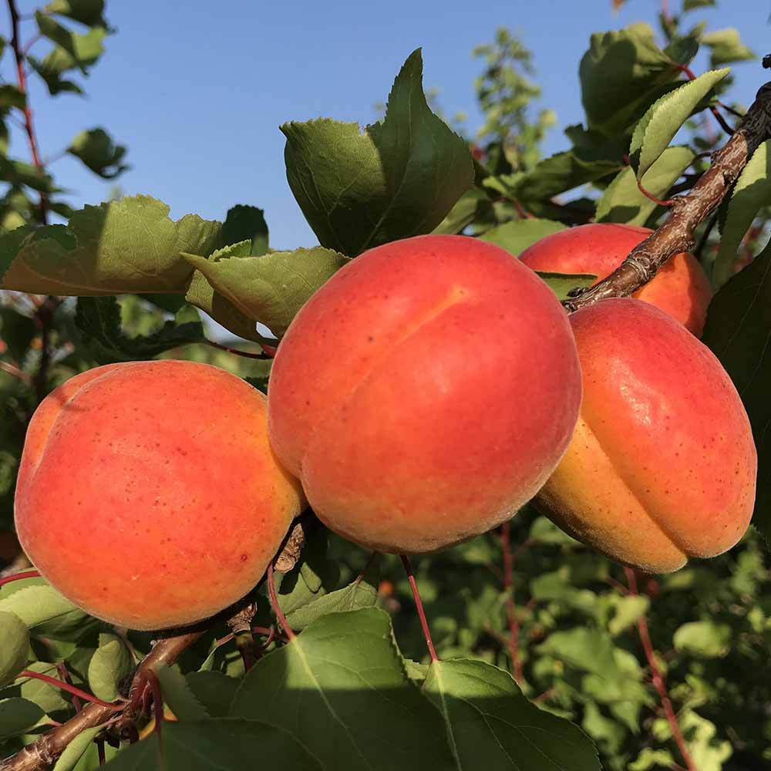 |  | Apricot  Variety – Milord  Picking date – 05-15 July  Shape – Round  Firmness – Very good  Cracking – No  Skin color – Yellow-red  Size – AA-AAA  Sugar level – 17° Brix
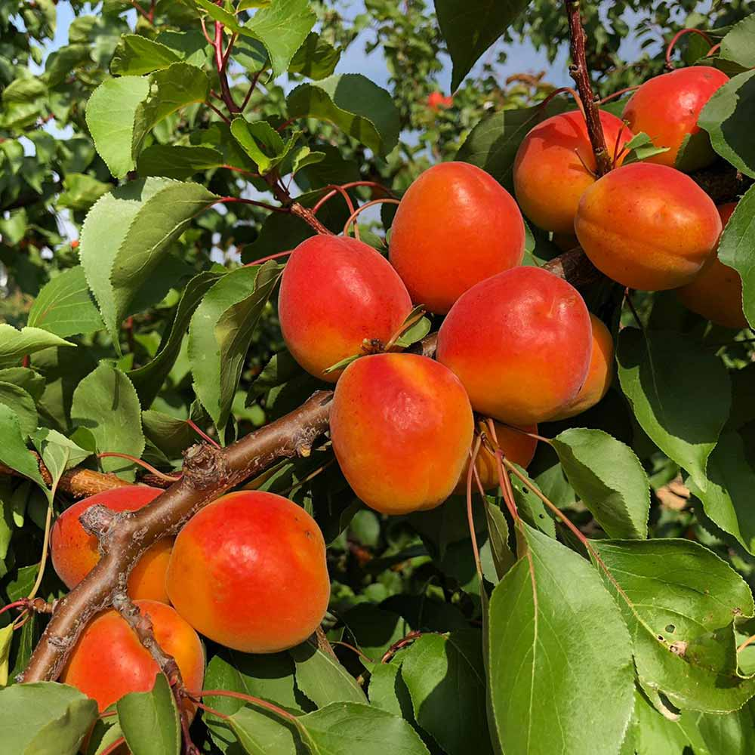 |  | Apricot  Variety – Madrigal  Picking date – 10-20 July  Shape – Round  Firmness – Very good  Cracking – No  Skin color – Orange-red  Size – AA-AAA  Sugar level – 19° Brix

